MySchoolBucks Detailed Instructions

Fairfax County Public Schools (FCPS) works with a third-party organization, MySchoolBucks, to facilitate on-line payment of class dues/dinner/donations, testing fees, Saxon Scope, field trips, and other activity fees. MySchoolBucks is also used to electronically add funds to FCPS cafeteria balances.
https://www.myschoolbucks.com

Families need to enroll in MySchoolBucks (MSB) once and that account will be used for all children from all schools within Fairfax County. MSB works with the county's student information database (SIS). The email address that is used to establish a MSB account must match the one on file in SIS. If a parent is having trouble establishing a MSB account, it is likely because the email address doesn't match the one on file with FCPS. Parents can update this information using the following link: https://www.fcps.edu/node/30943

Once enrolled, families can add items to their “Cart” for students from all schools participating in “on-line payment” and make a single payment for all back-to-school payments made directly to FCPS.

NOTE: Payments to PTSA/PTOs, Boosters, and other organizations supporting Langley High School and other schools in FCPS are made via those respective organizations and NOT via MySchoolBucks. One way to think of it: in prior years if you wrote a check to Langley High School or LHS Class of 20??, now you will use MySchoolBucks. If you wrote a check to LHS PTSA, Langley Boosters, etc – you will continue to pay those organizations separately.

Finally, you can always write a check to Langley High School and send to Langley High School (6520 Georgetown Pike, McLean, VA 22101) with the appropriate form (links can be found at http://www.ptsalangley.org/ ).

This document provides detailed screen shots for some common items paid using MySchoolBucks. If you have further questions or need additional information, please contact your class parents. (http://www.ptsalangley.org/ )

If you are ready to get started without further instruction:
https://www.myschoolbucks.com

If you need assistance, use the following links to jump to the appropriate section of this document for step-by-step instructions and screenshots:

Enroll in MySchoolBucks

2018-2019 Class Dues in Back to School Packets in MySchoolBucks

FAQs

Enroll in MySchoolBucks

- https://www.myschoolbucks.com or Download the App
- Click “Sign up today!”
- Select, “Virginia”, “Fairfax County Public Schools”
- Create User Profile (email address, password, security questions)
- Add a Student(s) to your account using Student Name, Date of Birth, and FCPS Student ID number

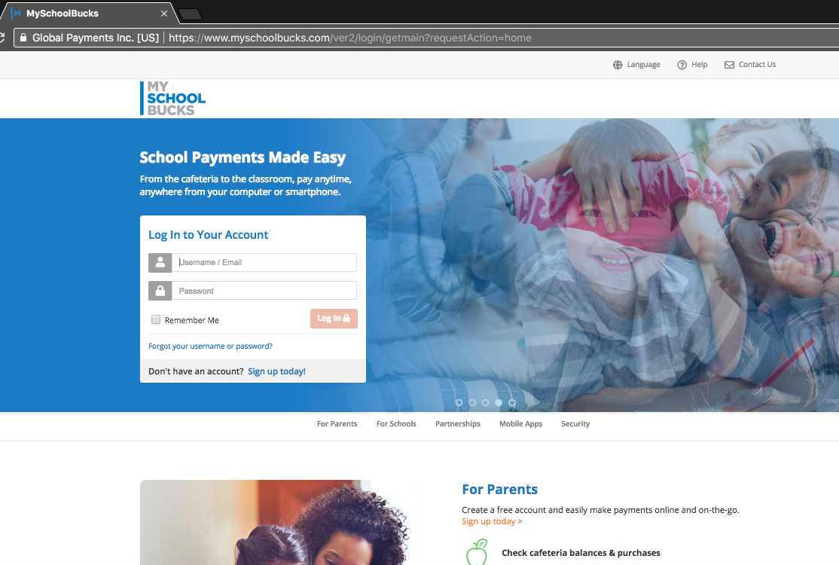
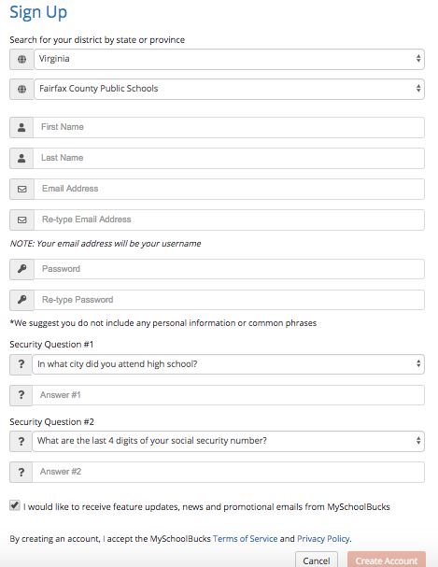

2018-2019 Class Dues in Back to School Packets in MySchoolBucks

- Login to your account at https://www.myschoolbucks.com or Download the App and login on the App
- Click on “School Store”… “Browse All Items”
- Select the Class Dues for your child’s graduation year
- Select appropriate student name for that class
- Select desired t-shirt size (Homecoming class t-shirt)
- Select “yes” to receive class communications
- Enter up to two email addresses for class communications
- Click “Add to Basket”
- Select the Dinner icon for your child’s graduation year
- Select appropriate student name for that class
- Select quantity of dinner tickets (need tickets for all attendees)
- Click “Add to Basket”
- Select the Donations icon for your child’s graduation year
- Enter amount of your donation (thank you!)
- Select appropriate student name for that class
- Click “Add to Basket”
- Repeat steps above for other items, e.g., PSAT Score Report for Juniors, Saxon Scope Home Delivery, etc.
- Repeat steps above for other students (at Langley and other schools)
- Once finished, click on Shopping Cart icon to View Cart and Checkout
- Enter your payment information and complete your “purchase”
- You will receive an email confirmation. Please save this in case there are any discrepancies.
- MySchoolBucks/FCPS sends all of the information to Class Treasurers so that they can order the appropriate T-shirt sizes and quantities of food for class dinners.

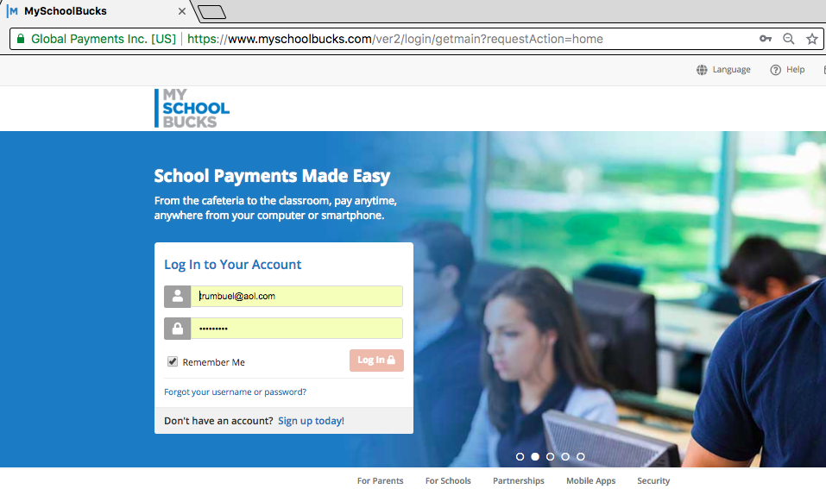

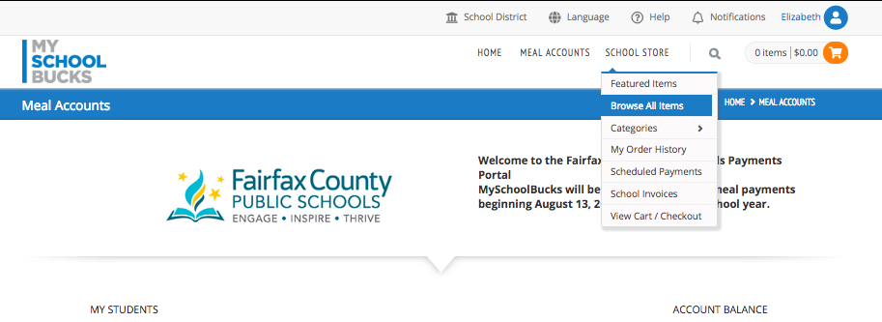
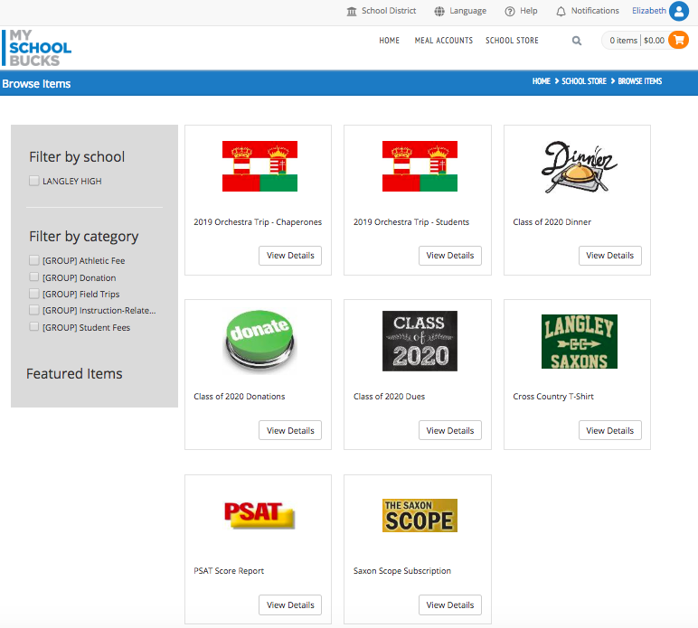
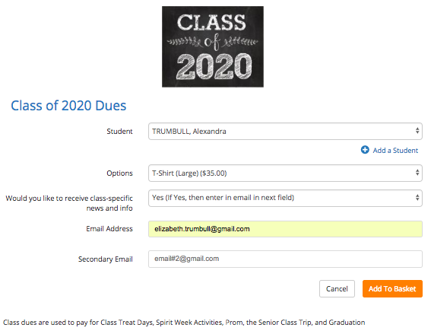
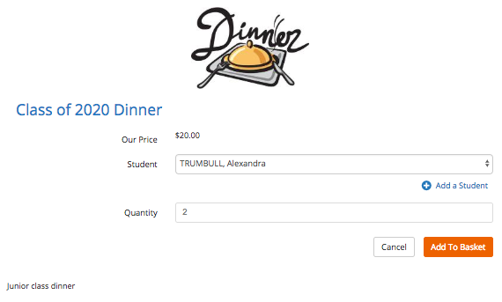
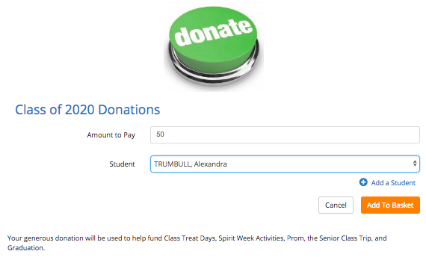

FAQs

https://www.myschoolbucks.com/ver2/help/gethelp

Does a parent need to add their student, or is there a way to automatically populate the class?
MSB is used by all schools in FCPS. When a parent creates a MSB account, they are the only ones that can add their children to their account. It is not done automatically and only needs to be done once. If the MSB account was established when your child was at another school (ex. Cooper), the information will follow your child to their new school.
All children in FCPS are managed via one MSB account.

How do I find my student’s class dues/dinner/donation information?
After logging into the App or https://www.myschoolbucks.com ,
click on “School Store”… “Browse All Items”.
If you are seeing too many items, you can use Filters on the left to narrow down the search by school or category.
NOTE: LHS Class Dues and Dinner icons are in the “Student Fees” Group. LHS Class Donations are in “Donation” Group

